# QUIZ - By one's own bootstraps

## Question 1

Parte superior do formulário

**Below are some statements about the process of bootstrapping.**

Select the **FALSE** statement.

We use bootstrapping to estimate how large our sampling error could be.

In bootstrapping, we repeatedly take new “samples” by sampling with replacement from our original sample.

**Bootstrap re-sampling is taking a lot of smaller samples from our original sample.**

When the sample size is not too small, re-sampling variation behaves very much like sampling variation.

We can use bootstrapping to put confidence intervals around means, proportions, the slopes of trend lines and much more.

Bootstrap confidence intervals do not allow for systematic biases.

**Correct**

This statement is **FALSE** – the re-samples should be of the same size as the original sample (and we sample with replacement).

Parte inferior do formulário

## Question 2

Parte superior do formulário

**Below is a bootstrap re-sampling distribution of BPSysAve (systolic blood pressure in mm Hg) from VIT.**

The data is from a sample of 50 people from the American population and we are using it to estimate the mean Systolic Blood Pressure for the American population. The plot comes from the VIT animation after 1000 re-samples have been taken. (There are some missing values for this variable.)

[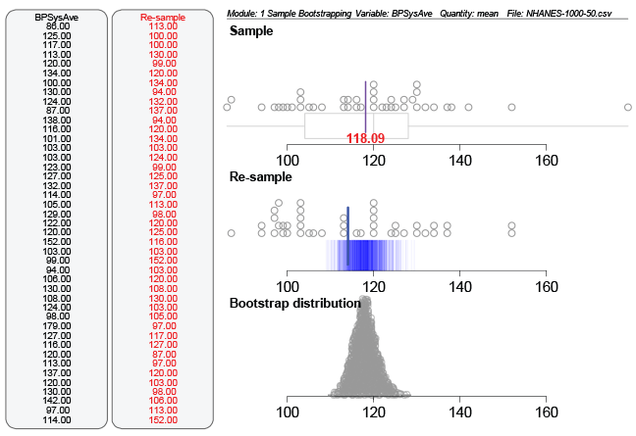](https://flexiblelearning.auckland.ac.nz/data-to-insight/8/1/images/quiz1b.png)  
Select the statement that is **FALSE**.

The mean value of **BPSysAve** for the sample is 118.09 mm Hg.

In the re-sample displayed in the middle panel, 152.0 was chosen twice.

The circles in the re-sample plot (middle panel) are the different re-sample means.

The Bootstrap distribution lets us see the extent of re-sampling error.

We would expect the mean blood pressure for the population to be somewhere between about 112 and about 123 mm Hg.

The darkest blue lines show the most common re-sample means.

**Correct**

This statement is **FALSE** – The circles in the re-sample plot are the individual values for one re-sample (red numbers) selected from the sample (black numbers on the left).

Parte inferior do formulário